Keap Chamber Program &

Educational/Training Seminars

Last Updated: May 26, 2020

Endorphin Digital Marketing
24 Fourth St., Troy, NY 12180
Phone: 518.250.9035
Web: www.EndorphinDigital.com
Email: info@endorphindigital.com

SMB Workshop Program Overview
Keap, previously known as Infusionsoft, has been helping small businesses succeed since 2001.

One of the many ways we are doing this is with Keap's SMB Workshop Program, at no cost to your organization or to your members.

The program starts with workshops and webinars from our world-class presenters - sharing content SMBs are hungry for, like:

● Step Up Your Local Online Game
● How to Recession-Proof Your Small Business
● Advanced Email Marketing – Beyond Basics
● Small Business Strategies for Earning Repeat Sales and Customer Loyalty
● Getting More Leads and Sales
● ...and more!

All presentations are "pitch-free" - meaning, your members will not be seeing sales presentations. They’ll get valuable and actionable knowledge and tools – to see real results to help grow their business.

As a participant in this program, we simply ask that you host and promote an average of at least 1 workshop or webinar per quarter for your members.

Some of the program benefits we've designed specifically to serve you and your members:

● Offer your Members these benefits:
○ World-class workshop and webinar content
○ Access to Keap’s industry experts and global resources
○ Members who sign up for a Keap account also receive:
■ Member Exclusive Discount
■ Free 24/7 Support from Keap

● Promotion of your event by Keap, to Members and prospects:
○ Effective marketing, such as:
■ Keap.com website event listing
■ Automated marketing campaigns for use with your Keap account

● Free Keap Pro account – our all-in-one CRM, sales and marketing automation software (learn more about Keap here)
○ Includes Keap Pro account setup:
■ Data Migration
■ Automated Campaigns:
● Event Invite Email & Registration campaign
● New Member Welcome campaign
● Newsletter Email Templates
● “Recommend Keap” campaign

Have questions or ready to get started with Workshop Program, contact:

Erik Bunaes
Endorphin Digital Marketing
Phone: 518.522.9917
Email: erik@endorphindigital.com

Current Classes

Keep Growing - More Leads More Sales and More Revenue

You've been using digital tools like Email and Social Media for your business. Are you growing? Are you successful at follow up with your leads? Is it getting easier? If you're feeling distracted, think you are doing too much, or not absolutely sure what you should be doing next, let us help you master smart and simple ways to drive your business to success.

How to Recession-Proof Your Small Business

It’s no wonder many small business owners easily lose confidence and give up too quickly instead of plowing through the tough times. But in many cases, that’s the exact opposite reaction small business owners should have. There are things you can do to improve the health of your business and turn things around.

In this presentation, we'll cover:

- Common reasons small businesses fail
- Takeaways from large, multi-billion businesses which struggled and made a successful comeback
- Things you can do to make your business “recession-proof”

Small Business Strategies for Earning Repeat Sales and Customer Loyalty

Repeat sales and customer loyalty are undoubtedly some of the most critical aspects of a small business being sustainable and able to experience healthy growth.

In this presentation, we'll cover:

- Why customer loyalty and retention can be even more important than acquiring new customers
- Methods of generating repeat business and inspiring client loyalty
- Tools to help you grow repeat sales and retain clients
- Strategies used by small business owners to keep clients coming back for more

Small Business Assessment and Planning Framework

Many business owners find themselves asking questions like, “I have an awesome product/service… why don’t more people buy it?” or, "I know I need to do some things differently in my business… but where do I even start?”

The Small Business Assessment and Planning Framework provides small businesses with the insights and specific steps necessary to take action and get results quickly, in their sales and marketing investments.

Conquer the Chaos

Based on the book by Keap founders, Clate Mask and Scott Martineau, titled “Conquer the Chaos”, this presentation will help you better understand the chaos so you can stop running from it and meet it head on, to gain better control of your business.

New Classes Coming Soon!

The Buyer's Journey

Simply defined, the Buyer's Journey is: a way for you to create a predictable process that will keep both you and your prospects in sync. Instead of pulling them through the sale, you’ll guide them through a simple journey that ends in a confident and mutually agreeable decision.

The Perfect Customer Lifecycle

Most business owners KNOW they have opportunity slipping through the cracks, but they don’t know what to do about it. In this actionable discussion, we’ll uncover that hidden opportunity.
Professional Speaker & Trainer

Erik Bunaes
KEAP Certified Partner and Mentor Trainer
Endorphin Digital Marketing, President & CEO

Erik Bunaes is a corporate-trained business consultant and recognized expert in digital marketing. With more than three decades of experience in financial services, management consulting and entrepreneurial ventures, he provides strategy and digital marketing guidance and services to a variety of clients on a nationwide basis.

In his role as a professional speaker and trainer, Erik has conducted 300+ educational marketing classes, seminars and webinars since 2011 at chambers of commerce, professional associations, conferences, industry forums, universities and private events.

Erik graduated from St. Lawrence University, earned an M.B.A. from the University of Colorado and spent 15 years working in Silicon Valley before relocating back to New York State in 2011.

See more about Endorphin Digital Marketing at www.EndorphinDigital.com and about Erik’s background on LinkedIn at www.linkedin.com/in/erikbunaes.

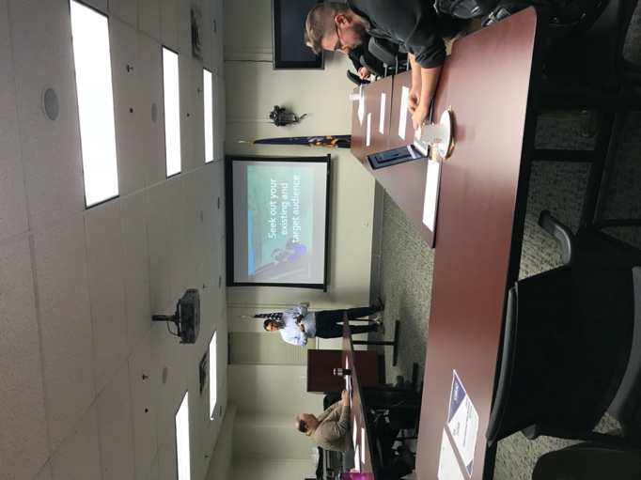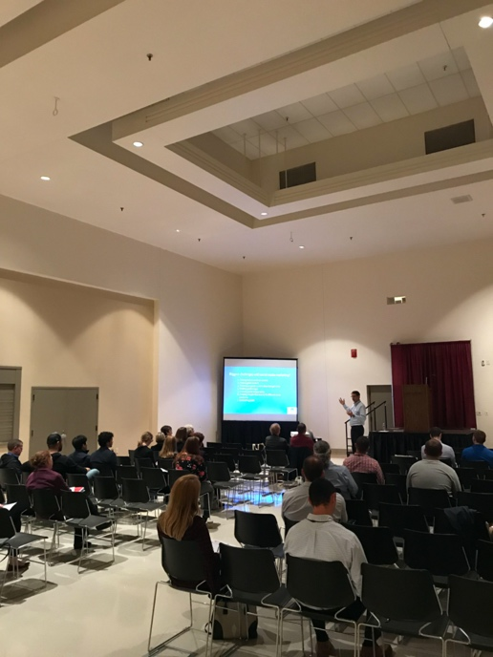

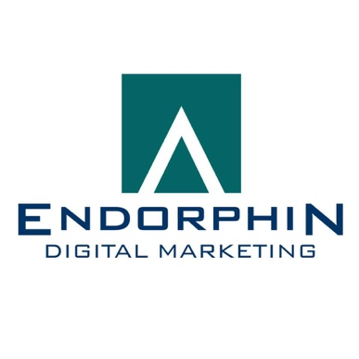
About Endorphin Digital Marketing

Endorphin Digital Marketing is a unique, full-service, strategy and digital marketing firm. Since 2005, we have specialized in marketing strategy, digital marketing and web design. We also offer content marketing and strategic planning.

In marketing technology, we enjoy close working partnerships with industry-leading companies including Constant Contact, Keap/Infusionsoft, PromoRepublic, Hootsuite, Google and more. These important relationships help us stay on the cutting edge of marketing best practices and technology solutions.

Our clients engage us for our knowledge of business, our passion for marketing and our love of technology. We specialize in working with professional services firms.

Please visit us at www.EndorphinDigital.com.

